We're thrilled to announce that Version 1.0 of CRT PARS (Payroll Allocation and Reporting System) is officially live

The application is designed to feel familiar. If you've used the ResNav version of PARS before, the workflow will be very similar, so the transition should be smooth. Please refer to the attached screenshots for a step-by-step walkthrough of how to:
• Add individual allocations to each timecard entry
• Acknowledge your timecards for management review

Part 1. Accessing the Application
Click the link below to open PARS, then sign in using your CRT account credentials:
🔗 https://apps.crtct.org:8056/
If you login and no account has been found, please submit a ticket to IT and an account will be created for you. 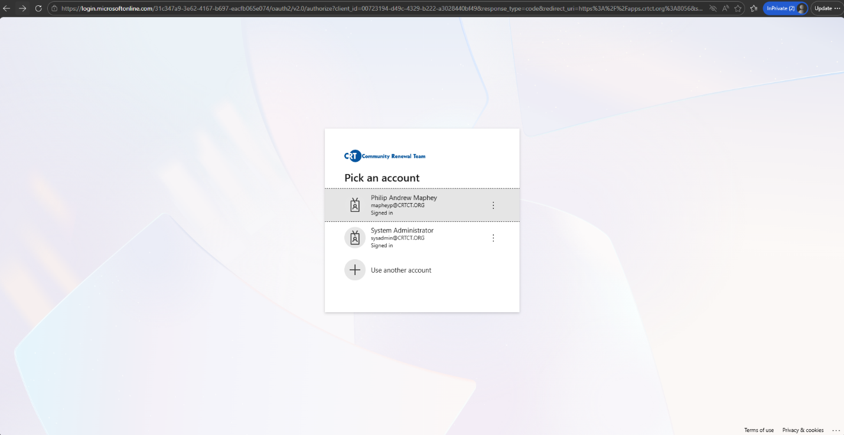
Part 2. Your Allocations Screen
Once logged in, you'll be brought to your personal Timecard Allocations screen. Here you'll find a Pay Period dropdown selector and a list of each workday within that period, each pre-populated with its required hours.

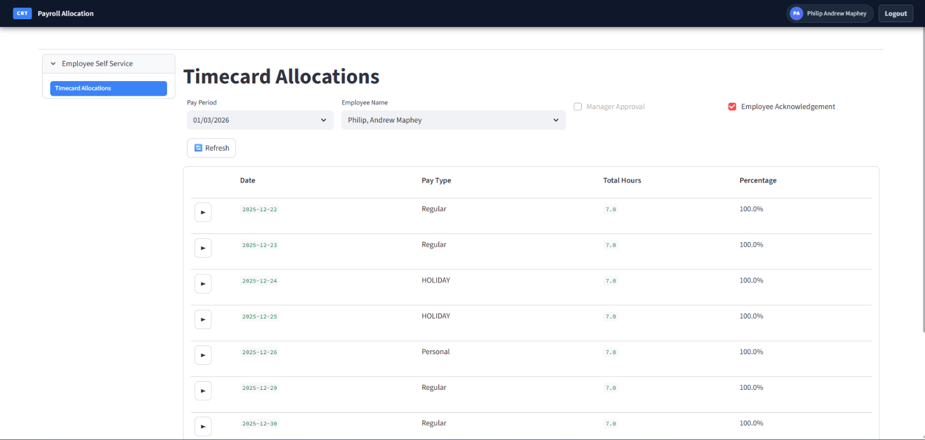
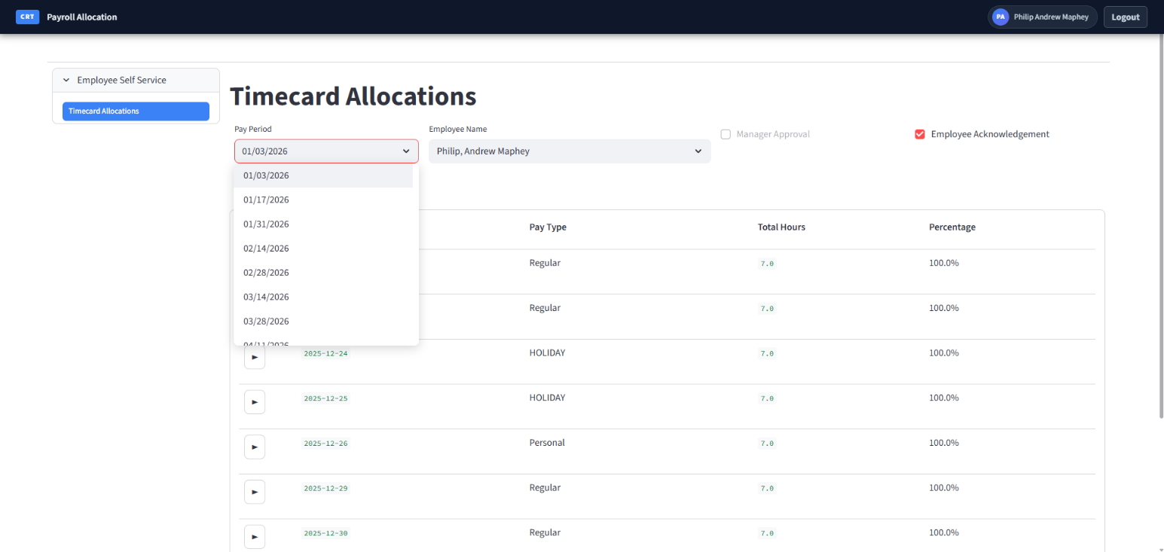

Part 3. Enter Your Allocations
Click the arrow (▶) to the left of any date row to expand it. This will reveal the allocation entry area where you can assign your Tasks, Fund Codes, and Hours for that day.
• Your fund codes have already been pre-loaded to your account — you will only see the codes that apply to you.
• The Total Hours column shows the required number of hours you must allocate for each day.
• Once the full hours for a day are accounted for, click Save Allocations to save that day's entries.
• If the amount of total allocated hours for a single day does not match the Total Hours it will not allow you to save. Only when you have matched your allocation and the total hours will the save button appear.
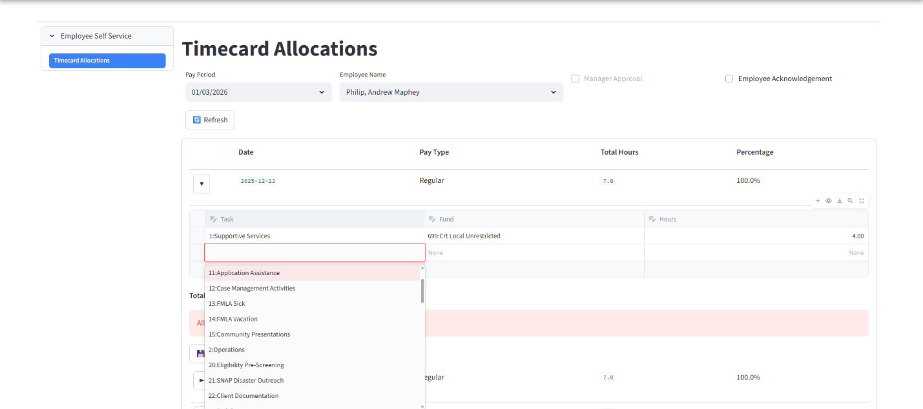

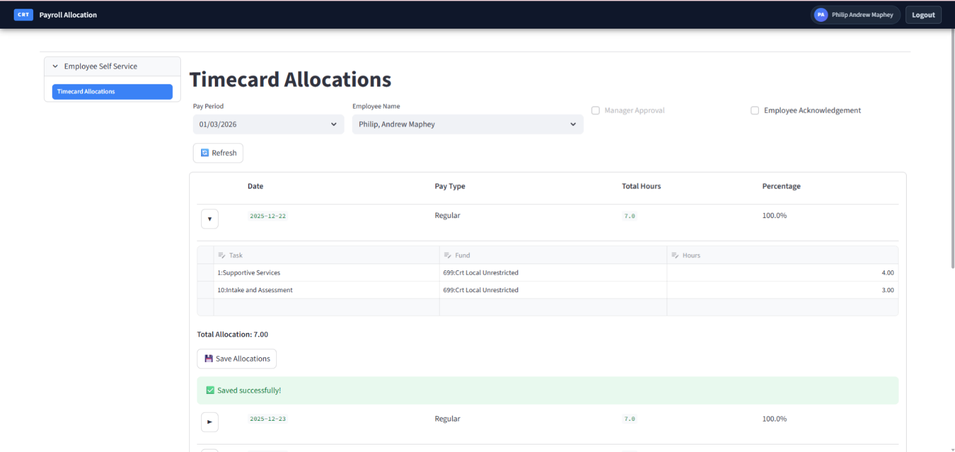

Part 4. Acknowledge Your Timecard
After completing all allocations for the pay period, check the Employee Acknowledgement box to submit your timecard for management review. Then you're all set — simply move on to the next pay period!
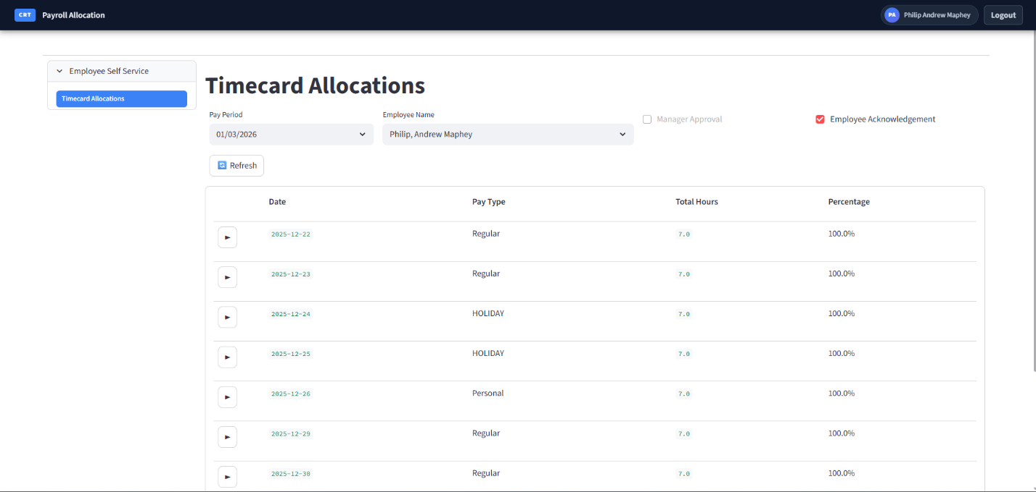

Once you have completed your allocations for a given pay period please email your manager that the pay period has been allocated for!

MANAGERS ONLY ACCESS
Part 5. Manager Approval Of Timecard
For managers you have access to view each of the employees in your departments time cards. After and employee submits and Acknowledges their time cards you will then review the time card and Approve It by checking off the box next to Manager Approval.
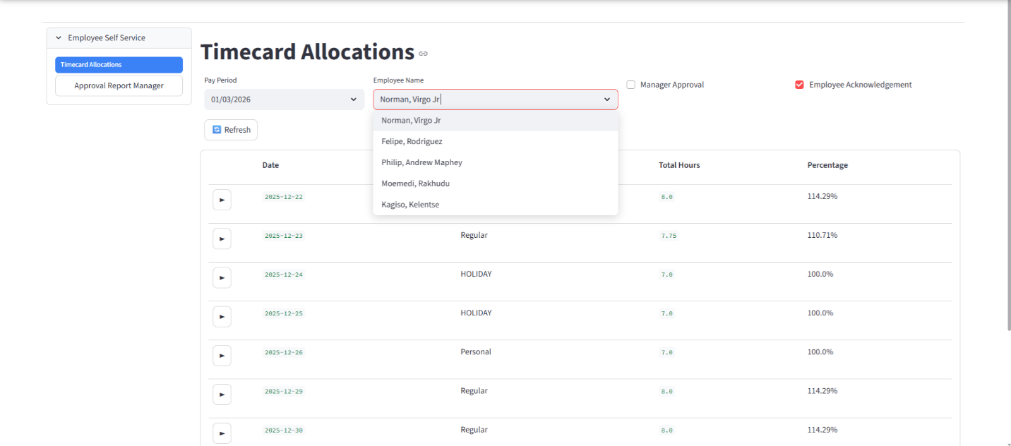
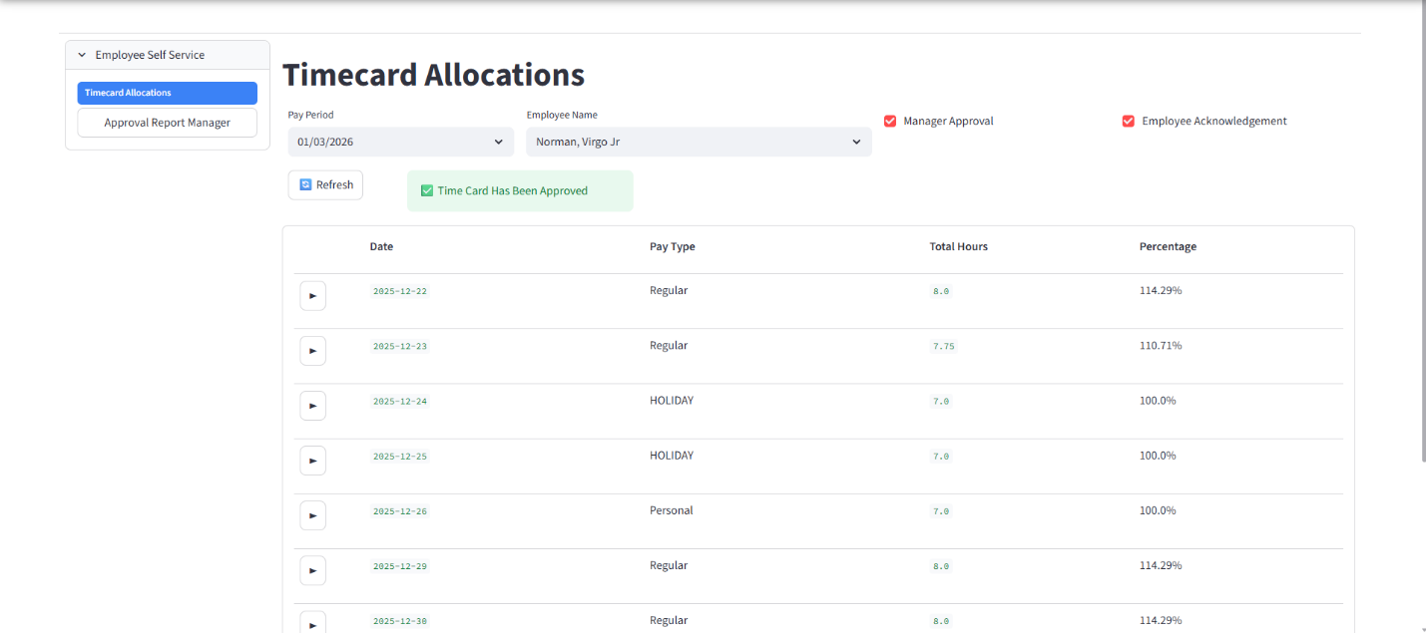

Part 6. Approval Report Manager.
To view all employees timecards by pay periods simply select Approval Report Manager under Timecard Allocations in employee self service. This will give you a quick view of the approval information and time for each time card.
